SET-9 — Online Learning Activity Analysis
AIM
To analyze online learning activity using R programming and visualize quiz scores, course-wise performance, study time, videos watched, and monthly quiz performance.
ALGORITHM
- Start RStudio.
- Import the Online Learning Activity dataset.
- Convert Login_Date into Date format.
- Create a histogram for Quiz Score.
- Create a boxplot of Quiz Score by Course.
- Create a scatter plot between Study Time and Quiz Score.
- Represent Videos Watched using bubble size.
- Apply transparency to the scatter plot.
- Calculate average quiz score per month.
- Create a line chart for monthly average quiz score.
- Apply moving average smoothing.
- Display the graphs.
- Stop.
R CODE
data<-data.frame(Student_ID=c("L01","L02","L03","L04","L05","L06"),Gender=c("Male","Female","Male","Female","Male","Female"),Age=c(20,22,19,21,23,20),Course=c("R","R","SQL","R","R","SQL"),Study_Time=c(3.5,4.2,2.0,5.0,2.5,4.0),Videos_Watched=c(12,15,8,18,9,14),Quiz_Score=c(78,85,65,92,70,88),Login_Date=c("2025-01-05","2025-01-05","2025-02-08","2025-02-08","2025-03-12","2025-03-12"))
data$Login_Date<-as.Date(data$Login_Date)
hist(data$Quiz_Score,main="Distribution of Quiz Scores",xlab="Quiz Score",ylab="Frequency")
boxplot(Quiz_Score~Course,data=data,main="Quiz Score by Course",xlab="Course",ylab="Quiz Score")
plot(data$Study_Time,data$Quiz_Score,cex=data$Videos_Watched/5,pch=19,col=rgb(0,0,0,0.5),main="Study Time vs Quiz Score",xlab="Study Time (hrs)",ylab="Quiz Score")
data$Month<-format(data$Login_Date,"%Y-%m")
monthly<-aggregate(Quiz_Score~Month,data=data,mean)
plot(monthly$Month,monthly$Quiz_Score,type="o",main="Average Quiz Score per Month",xlab="Month",ylab="Average Quiz Score")
ma<-stats::filter(monthly$Quiz_Score,rep(1/3,3),sides=2)
lines(monthly$Month,ma,type="o")

OUTPUT
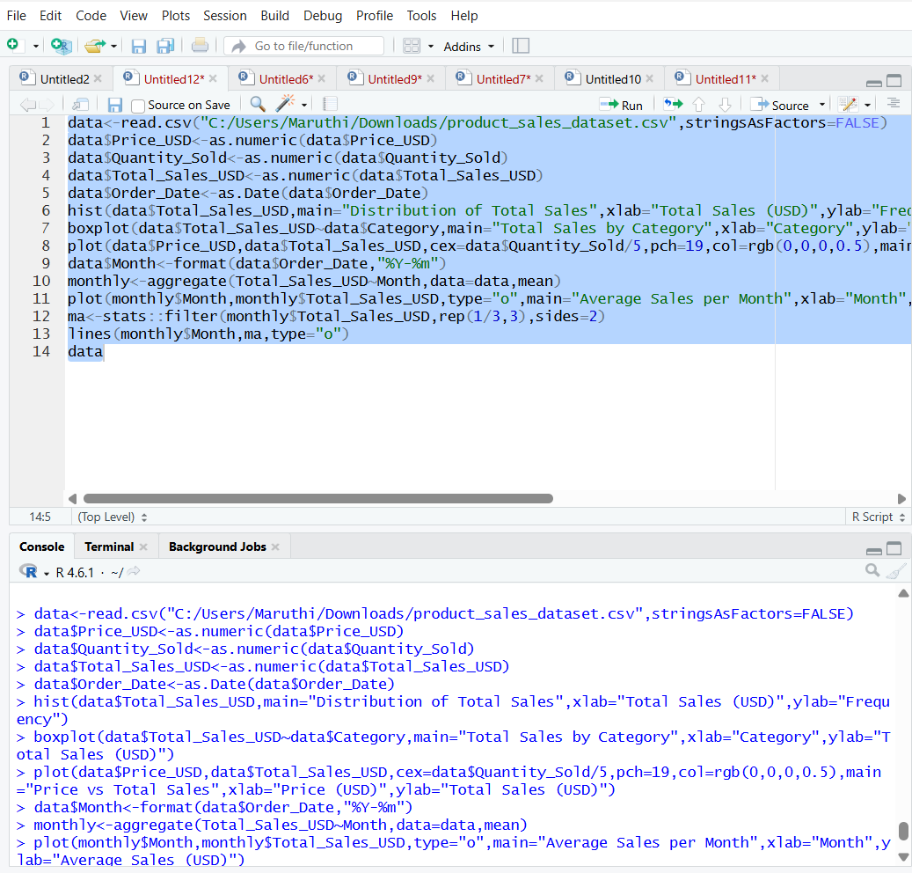RESULT
Thus, the Online Learning Activity data was successfully analyzed using R programming. The histogram, boxplot, scatter plot, and monthly average quiz score line chart were successfully created to visualize student learning performance.
ChatGPT can make mistakes. Check important info.

